**Problem A: Seek Treasure in the “Maze”**

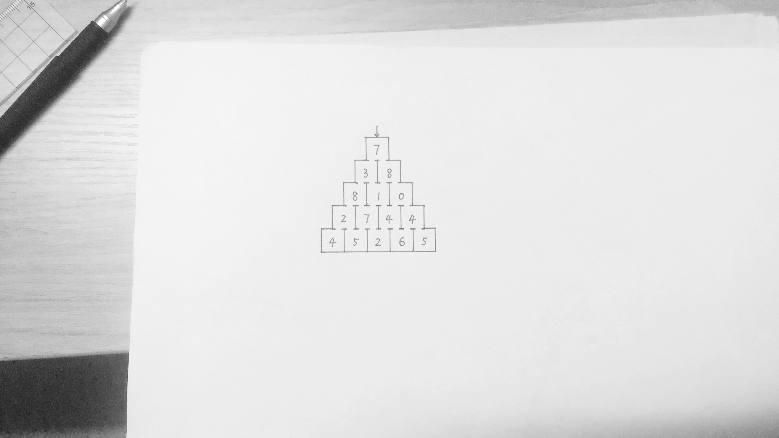Hugo is playing an interesting—actually boring—game called “Maze”. There is some treasure buried in every room of this maze. But Hugo can only go downward to the rooms at the bottom. Luckily, he has got a treasure map. He is wondering how he can go through a 𝑛-level maze and get as much treasure as possible.

Hugo

For example, 7+3+8+7+5=30 is the best route for

Hugo to get most treasure through this maze.

n=5

**Problem B: North Korea is Launching Missiles**

North Korea is going to launching missiles to attack Korea before the complete installation of THAAD! Korea has found the secrets that North Korea will 𝑛 missiles continuously. The $i^{th}$ missile can only be intercepted at height $h_{i}$. Korea’s interceptor can only intercept a sequence of missiles with decreasing $h_{i}$.Please find out how many missiles could be intercepted by Korea at most.

e.g. $\{h_{i}\}=1000, 5000, 2500, 6000, 500$

Korea will intercept the missiles highlighted above.

**Problem C: Let’s Take a Group Photo**

Prof. Kindratenko wants to take a group photo for us. We ( $n$ people) line up in a row. The height of the $i^{th}$ person is $h_{i}$. But Prof. Kindratenko thinks that our formation is bad due to irregular heights. He makes a interesting rule that the distribution of heights should be like $h_{1}<h_{2}<…<h_{i-1}<h_{i}>h_{i+1}>…>h_{n}$. So in a strange way though, Prof. Kindratenko wants to “drive away” some people in this row. How many people should be “driven away” at least?

e.g. $\left\{h_{i}\right\}=177, 178, 176, 179, 182, 162, 170, 168$

Professor will drive away people highlighted above.

**Problem D: Take a Break**

By accident, Tutor Wu got to know the working schedule next Monday. On the schedule, there are $n$ tasks, the $i^{th}$ of which takes up a time interval $[s_{i}, t_{i})$ (all integer values within the working hour). The working hour for Tutor Wu is $[1, T_{0}]$ (integer). Here are some interesting working rules for him:

1. If he is busy at $s_{i}$, he doesn’t need to work on the $i^{th}$ task.
2. If he is taking a break at $s_{i}$, he must go for work.
3. (2 continued) If $s_{i}=s_{j}=s_{k}$, he must choose one.

Please help Tutor Wu to work less!